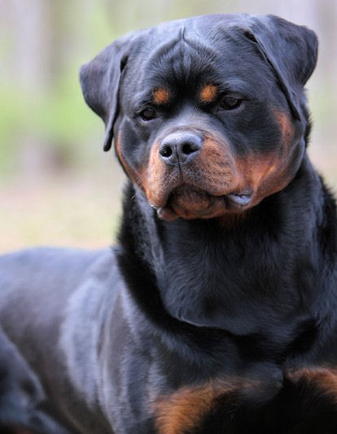 |  | Ajax  Von hause Drazic  JLPP CARRIER RO-LPP360/19M-PI-CAR  CARDIAC RO-CA7444/18M/VPI  PATELLAR RO-PA778/18M/P-VPI  DENTITION RO-DE1230/18M-VPI  HD B ED 0 KSS
Profile  Sire: Dzomba von hause Drazic  Dam: Jolly Alpha Canis Rott  D.O.B. 06.12.2015  AKC # WS54801301 / JR 730221 JR  DNA # V797840  Microchip 688035000142513  Breeder: Dusko Sreckovic  Handler: Dusko Sreckovic  Ajax is a large robust stud dog that produces Excellent bone and substance, Amazing temperaments, dark brown eyes and mouth pigment. Beautiful top and underlines, correct leg angulations and tight pasterns.  Contact  PHONE:  615-973-1874  WEBSITE:  VDRrottweilerbreeders.com  EMAIL:  Lavallee.vdmsr@hotmail.com  handler and training  25 years owning Rottweilers  15 years show and training  Drive building  Sieger Preparation  breeder experience  20 years breeding |  | Health  [HIPS AND ELBOWS]  07.18.2018  STUD BOOK KSS  KSS NO. JR 730221 RW  HIPS HD B  ELBOWS ED 0  Veternarian “RADICEVIC” Belgrade Serbia  shows  PUPPY CLASS  [DATES FROM MARCH 2016 TO JULY 2016]  4X VP1 , 4 X VP2 , 3 X VP3 , 1 X VP5  3 X YOUTH WINNER  2 X BEST OF BREED  YOUTH CHAMPION , JUNIOR BEST OF BREED  BEST OF GROUP  INTERMEDIATE CLASS  [DATES FROM JANUARY 2017 TO JUNE 2017]  V1 , 3 X V2 , 2 X V2, 2 X V3 , V7  ADRK VDH V7 OUT OF 20 DOGS  HUNGARY V3 OUT OF 27 DOGS  ADULT AND OPEN CLASS  [DATES FROM JUNE 2017 TO AUGUST 2017]  6 X V1 , V2 , 5 X CAC, 2 X CACIB  3 X BEST OF BREED , BEST OF GROUP III  ADRK KLUSHOW V12 OUT OF 31 DOGS  ADULT MONTENEGRO CHAMPION  ADULT SERBIAN CHAMPION  CHAMPION CLASS  [DATES FROM JULY 2018 TO FEBUARY 2019]  2 X V1 , V2 , V4  SIEGER  BEST OF OPPOSITE SEX

